ASSIGNMENT 8.1

1.When to use (Rapid Application Development) RAD model
When not to use (Rapid Application Development) RAD model
RAD model can be used
- when the very fast delivery required and the skelton is ready i.e good hybrid model,
- budget is not constrained
- highly skilled experienced team
- process,data model are critical
- quality is not a matter
- customer involvement is more
RAD cannot be used when
- fresh team is handling
- cost is constrained
- If automatic generation tools are not there
- mulitiple tools do not exist
- quality is a matter

2.Define an ER diagram of a software Organization with all the relationship model that was discussed in the classroom
An entity relationship diagram tells about relationship between the entities and thier reprsentation
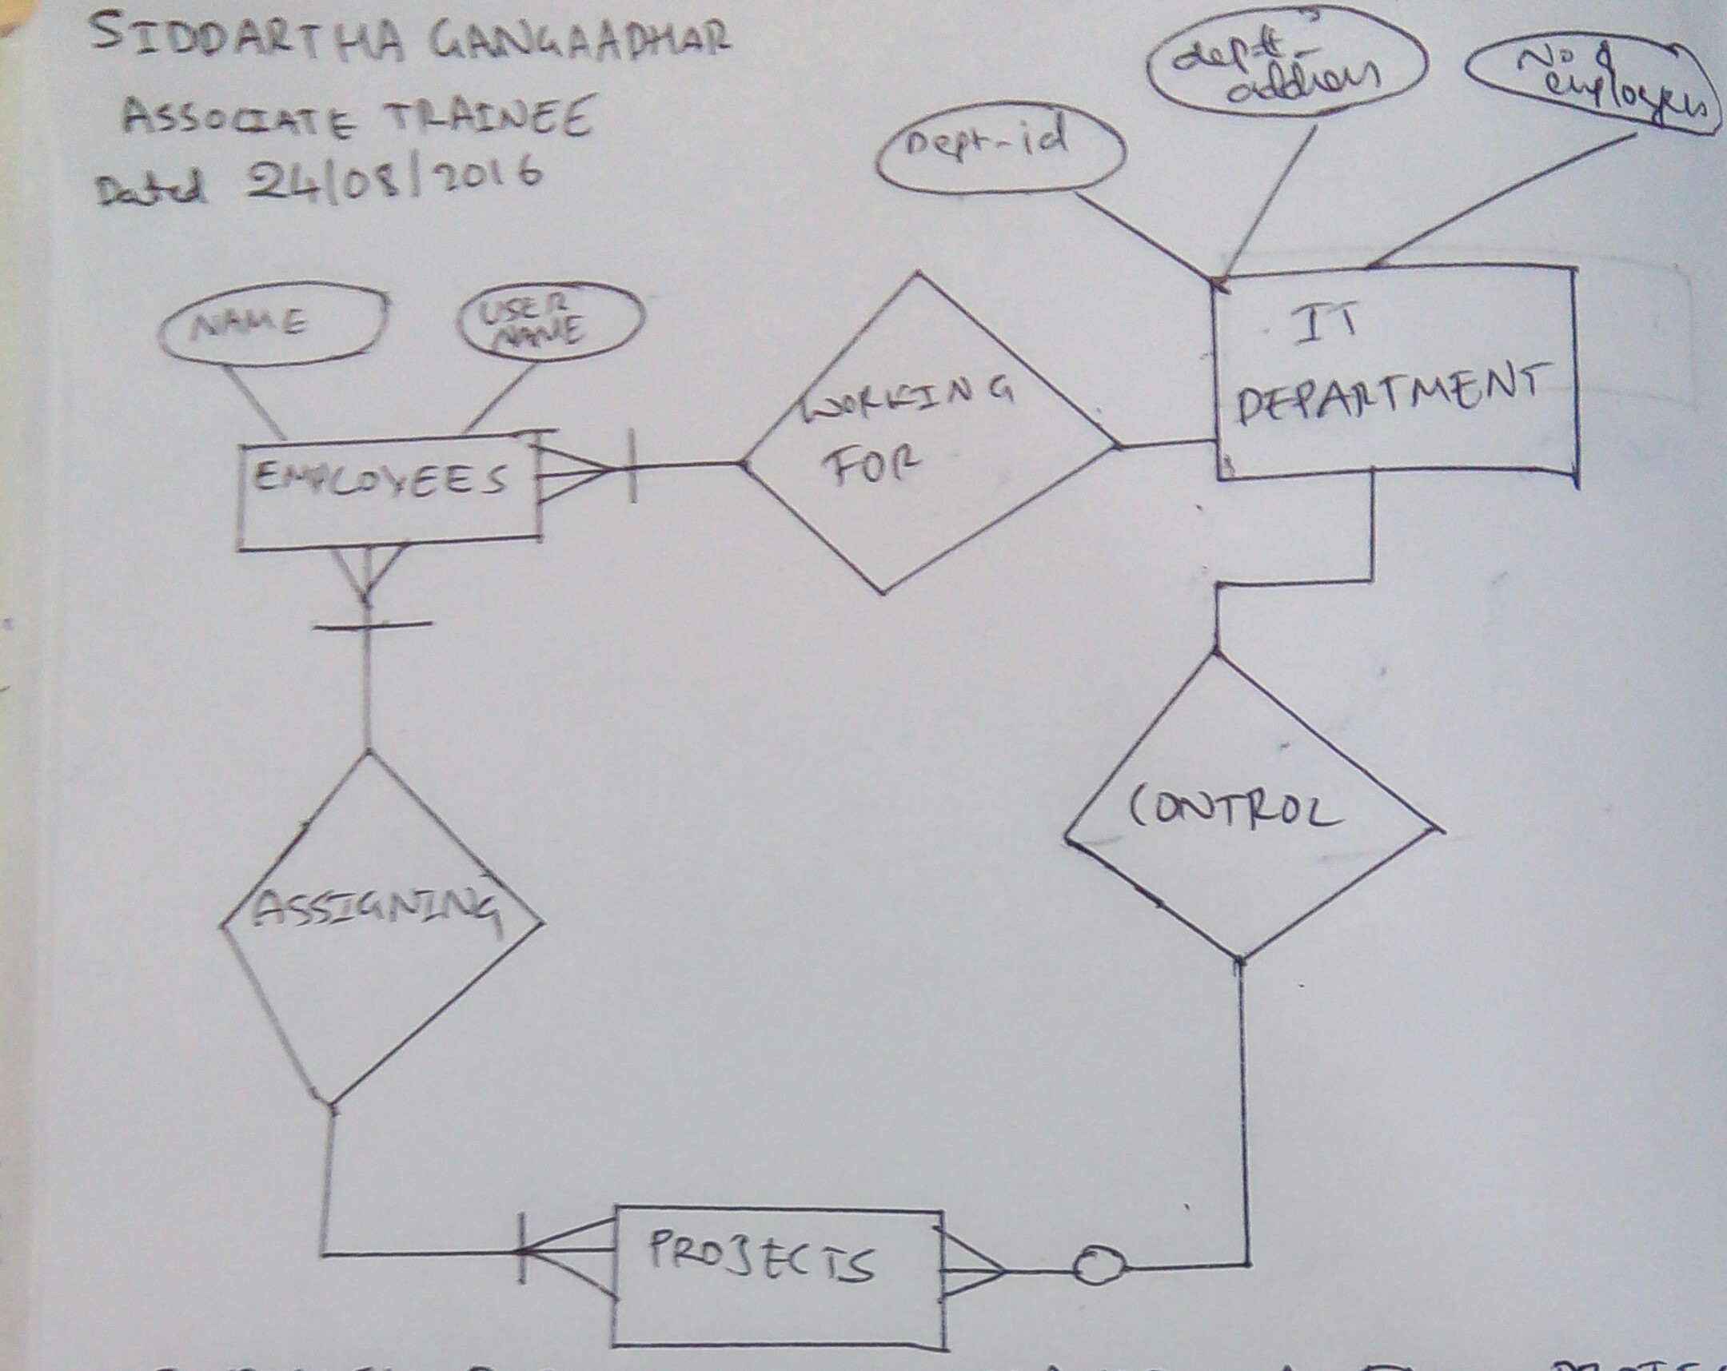
considering the below example ,which tells about how projects are assigned to a employees

Describe the Entity Relationships for the following diagram
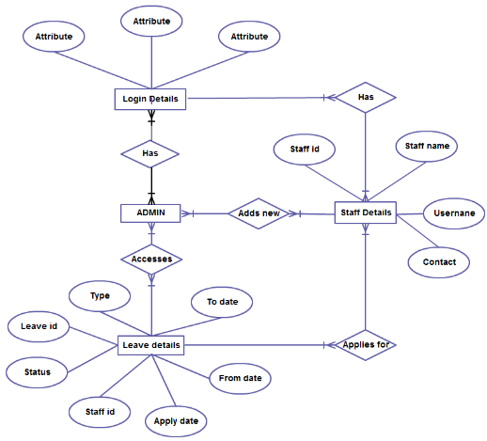
In the above example,
ENTITIES & ATTRIBUTES
- LOGIN DETAILS:attributes are staff name,id,user,contact
- ADMIN
- STAFF DETAILS:attributes are Staff id,Staff name,User name,Contact.
- LEAVE DETAILS:attributes are To live,From date,Apply date,Staff id,Status,Leave id,Type.

Relationship each admin has the login details -many to many relation.

- One or more Staff has the login details,Each staff has their login details.
- One or more Admin can add many new staff details to the account with attributes.
- One or more staff members can apply for leave by providing staff_id.
- One or more Admin access leave details about staff by staff_id .

